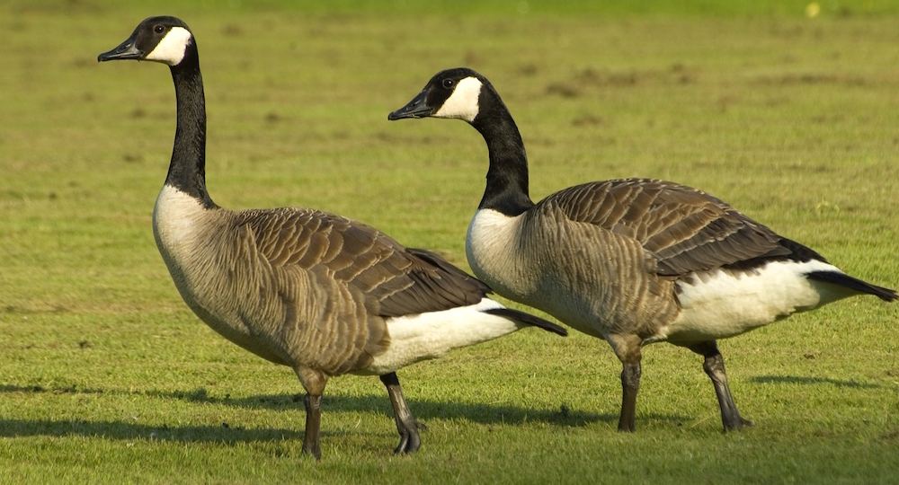

LETTERKENNY TOWN BOARD SPECIAL MEETING

A citizens’ petition has gathered sufficient signatures to be acted upon by the town board. The petition, presented by Mr. “Coach”, proposes humane poisoning of Canada goose eggs as a prevention measure for their droppings that interfere with play on the Letterkenny Gray Granite Copper Creek Whistle Ridge Golf & Country Club.